CARBON DIOXIDE EMISSIONS AND ECONOMIC GROWTH
Across African Nations (2000 – 2023)
SUBMITTED TO:
FEMTECH INFORMATON TECHNOLOGY INSTITUTENO 158, IBRAHIM TAIWO, ILORIN.
SUBMITTED BY:
GBADEGESIN MARIAM OMOWUMI

PROJECT SUPERVISOR
MR. RILWAN ADESOLA

COURSE: DATA ANALYSIS.
May, 2026
CERTIFICATION
This is to certify that this project titled Carbon Dioxide
Emissions and Economic Growth Across African Nations was carried out by
GBADEGESIN MARIAM OMOWUMI, Data Analysis Department, Femtech Institute of Information and Technology, Seeding Africa Programme. This work has been examined and approved as meeting the requirements for the award of certification in Data Analysis.
Gbadegesin Mariam Omowumi 9th April, 2026
Student’s Name Date

Mr. Adesola Rilwan 9th April, 2026
Project Instructor Date

Mr. Ayo Samuel 9th April, 2026
Project Coordinator Date

Miss Aderibigbe Elizabeth 9th April, 2026
Institute Admin Date

DEDICATION
This project is dedicated to every African student who has ever been told that data analysis is too complex or too technical. May this work demonstrate that with curiosity, discipline, and the right tools, data can tell powerful stories that change how we see the world. It is also dedicated to the communities across Africa who live with the consequences of climate change every day, despite contributing the least to its causes.

ACKNOWLEDGEMENT
I would like to express my sincere gratitude to the FemTech Information Technology Institute and Seeding Africa for providing this platform for practical, industry-relevant data analysis training. The structured guidance and mentorship received throughout this programme have been invaluable.
I am deeply grateful to my project instructor for their patience, direction, and constructive feedback throughout this project. Their expertise in data analysis helped shape the quality and direction of this work significantly.
Special appreciation goes to Our World in Data, the World Bank, and the International Energy Agency for making their datasets publicly available. This project would not have been possible without access to credible, open-access data sources.
Finally, I thank my fellow students, family, and everyone who offered support, encouragement, and understanding throughout this journey.
ABSTRACT
Africa is one of the most vulnerable continents to the consequences of climate change, but it makes insignificant contributions to global carbon dioxide emissions. The current research aims at establishing the connection between the increase in carbon-dioxide emissions and economic growth in 52 African countries over the period 2000 to 2023. Based on the data obtained from Our World in Data, World Bank, and International Energy Agency databases, this research will investigate whether growth in Gross Domestic Product is the major factor contributing to increased carbon dioxide emissions.

Among the key findings from the study include the fact that while total carbon dioxide emissions on the continent had risen by about 52% from 2000 to 2023, the Gross Domestic Product grew significantly faster over the same period, thus indicating partial continental decoupling. The high-emitting regions were established as being North Africa and Southern Africa, with the bulk of emissions emanating from South Africa, Egypt, Algeria, and Nigeria. Twenty countries in Africa showed signs of carbon-efficient growth patterns, particularly East African countries, and the most carbon-efficient country in Africa was identified as being Rwanda. Forty-three countries were established as being at high risk due to the higher-than-average carbon dioxide growth rates in their regions.

The study concludes that there is no automatic relationship between economic growth and proportional increase in emissions in Africa, although there are notable differences between different countries and regions. These findings can be used in developing policies aimed at assisting at-risk countries.
Keywords: Carbon Dioxide Emissions, Economic Growth, Gross Domestic
Product, Decoupling, Emission Intensity, Africa, Climate Change, Data Analysis.

TABLE OF CONTENT
Title Page………………………………………………………………………. i
Certification Page................................................................................................ ii
Dedication .......................................................................................................... iii
Acknowledgement ..............................................................................................iv
Abstract .............................................................................................................. v
CHAPTER ONE: INTRODUCTION
1.1 Introduction ..................................................................................................1
1.2 Definition of Terms ......................................................................................4
1.3 Statement of the Problem .............................................................................7
1.4 Objectives .....................................................................................................8
CHAPTER TWO: PREVIOUS PROJECT REVIEW
2.1 Previous Project Review ………..................................................................9
CHAPTER THREE: TOOLS AND PROJECT PROCESS
3.1 Tools Used and Justification…………........................................................ 13
3.2 Project Process ........................................................................................... 14
CHAPTER FOUR: FINDINGS AND RECOMMENDATIONS
4.1 Project Limitations ...................................................................................... 32
4.2 Recommendations for Research ................................................................. 35
4.3 Key Solutions and Benefits..........................................................................37
CHAPTER: CONCLUSION
5.1 Conclusion .....................................................................................................46
References ...........................................................................................................49

CHAPTER ONE
INTRODUCTION
1.1 Introduction
It is no coincidence that the connection between economic development and environmental sustainability has been one of the most discussed issues in policy circles in recent years. Indeed, as economies develop through industrialization, increased energy production, and infrastructure expansion, they produce carbon dioxide and other greenhouse gases that lead to climate change. The primary issue that has been at the forefront of discussions among policymakers, academics, and development agencies has always been whether economic development should come at the expense of harming the environment or whether there can be economic development without excessive carbon dioxide emissions.
Africa is an intriguing and fascinating place to conduct such a study. There are more than 1.4 billion people spread across 54 countries in different stages of economic development within Africa. According to the World Bank (2023), Sub-Saharan Africa has undergone rapid economic development over the last two decades due to commodity export, urbanization, increasing consumer markets, and rising foreign investments. Since 2000 until now, several African countries have witnessed the fastest growth in Gross Domestic Product.
And yet, while the continent is undergoing its economic boom, Africa's contribution towards carbon dioxide emissions on a worldwide scale is negligible. According to research conducted and reported by Our World in Data (2023), the entire African continent produces less than four percent of all global carbon dioxide emissions, despite being home to almost seventeen percent of the world's population. There are thus a striking contradiction and paradox here. Africa contributes the least towards the problem of carbon dioxide emissions and bears the brunt of their negative impacts. Droughts, flooding, increased temperature, food scarcity, and even forced migration of peoples.
It is thus important to study the nature of carbon dioxide emissions across different African countries for reasons beyond merely satisfying one's intellectual curiosity. Indeed, there are significant policy implications as well in the first place, such information will enable African governments to devise economic policies and directions to help them meet the demands of the people for economic prosperity and development without getting locked into an unhelpful carbon cycle. In addition, knowledge about carbon dioxide emissions in African nations is important in helping to decide who needs more financial assistance in addressing climate change issues.
In order to answer these questions in a data driven manner, Growth at What Cost? Carbon Dioxide Emissions and Economic Growth Across African Nations project was designed and implemented. Using the open-source data provided by such resources as Our World in Data, World Bank, and International Energy Agency, the project is focused on investigating the trends in CO2 emissions and economic growth, regional variations, as well as correlation between GDP and carbon production among 52 African nations during 20002023. The analysis was carried out using the combination of four different tools including Microsoft Excel, SQL, Python, and Microsoft Power BI software programs, the end-to-end solution of a data analyst.
The results obtained through the implementation of this project can be used not only by academic examiners, but all those who are interested in the topics related to development of Africa and environmental issues. At the completion of this report, the reader will find the answers to the questions posed at the beginning of the paper, specifically regarding countries causing emissions, decoupled nations, and necessary actions.
1.2 Definition of Terms
This list of terms will be encountered repeatedly within this report. These terms are explained below in simple language to ensure that understanding is not compromised by lack of expertise on the part of the reader.
Carbon Dioxide (CO₂): Carbon dioxide is a colorless, odorless gas that results mainly from the combustion of fossil fuels like coal, oil, and natural gas. It is the most important greenhouse gas involved in global warming. CO₂ emissions in this report will be presented in million metric tons emitted per year per country.
Gross Domestic Product (GDP): The Gross Domestic Product is the market value of all goods and services produced in an economy in one year. GDP is the main tool used to estimate the economic size and growth of an economy. GDP will be reported in this report in current US$.
GDP per Capita: GDP per capita is calculated by dividing the total GDP of an economy by its population.
Carbon Dioxide Per Capita: Carbon dioxide per capita is the amount of carbon dioxide produced by a country divided by its population size. This gives us the average amount of carbon emitted by each individual citizen, measured in metric tons per individual per year.
Emission Intensity: Emission intensity can also be referred to as the amount of carbon dioxide emitted per GDP unit. It is measured by dividing the total carbon dioxide emissions by GDP. The smaller this number, the better; because this means the country is producing a lot of economic value using relatively little carbon.
Decoupling: Decoupling refers to a situation in which a country's economic growth is outpacing the carbon dioxide emissions produced by the same country. A country is deemed to be decoupling when its GDP growth rate increases at a much greater pace compared to that of carbon dioxide production.
High Risk Country: In this particular project, we define a high-risk country as any country experiencing an average increase in carbon dioxide emissions that is faster than the average for the continent of Africa at 4.52% annually.
Gas Flaring: Gas flaring is the act of burning natural gas that comes up from the extraction of oil when the necessary infrastructure does not exist to harness the gas for commercial uses. This process results in large amounts of CO2 and CH4 emissions, especially in oil-producing African countries. Nigeria is a prime example of gas flaring.
Methane: Methane is a strong greenhouse gas emitted mainly as a result of agricultural operations such as rearing livestock, cultivating rice, and decomposing organic matter. Although the current paper mainly considers CO2 emissions, methane statistics are also included in the analysis as supplementary information.
Exploratory Data Analysis (EDA): Exploratory data analysis is a technique used to analyze a given set of data to discover the characteristics of that data and gain some basic insights before using formal statistical methods.
Climate Financing: Climate financing includes the financial means that have been made available by developed countries and international institutions to developing countries for adapting to climate change impacts and adopting green development strategies. The very small contribution of Africa to worldwide carbon dioxide emissions makes its case stronger for climate financing.
1.3 Statement of the Problem
Emissions of carbon dioxide from African nations have increased consistently since the start of the millennium, a period during which there has been significant economic growth on the continent. With increasing levels of industrialization, urbanization, and population growth across Africa, demand for energy has increased and therefore, so too has carbon dioxide emissions. What has not been fully investigated, however, is the extent to which these emissions have been influenced by economic growth as opposed to other drivers, including population growth, energy mix, or sectoral trends.
Also, it has been unclear just which African nations and regions are behind these increasing emissions, which nations are growing economically without experiencing such emission increases, and whether the data reflects the sustainability of Africa's current growth path.
This has created an important knowledge vacuum for decision-makers and organizations needing evidence to inform policies relating to energy and economic development, and climate finance distribution in particular.
The problem statement for this study is outlined below:
“Emissions of carbon dioxide by countries in Africa have risen in the past two decades together with GDP growth. It is unclear whether GDP growth is the main factor contributing to the rise in CO2 emissions, which countries or regions are most vulnerable to CO2 emissions, and which countries have managed to decouple GDP growth from CO2 emissions. The objective of this project is to explore answers to these research questions through credible data and analysis.”
1.4 Project Objectives
The current research is based on the following five objectives:
- To map and investigate trends in CO2 emissions in 52 countries of Africa from the year 2000 till 2023 with identification of those countries having the highest level of growth in emissions.
- To study the relationship between the growth of Gross Domestic Product (GDP) and CO2 emissions per each studied African country to find out whether there exists a link between them.
- To compare emissions of CO2 per capita and emission intensity in the main African countries' regions (North Africa, West Africa, East Africa, Central Africa, and Southern Africa).
- To single out countries having economic growth without CO2 emissions growth (or reduction of such emissions) and countries at high risk having more rapid emissions growth than economic growth.
- To formulate policy conclusions on the issue based on research results.

CHAPTER TWO
REVIEW OF PREVIOUS PROJECT
2.1 Review of Previous Project
There exists extensive literature on the interaction between economic growth and carbon dioxide emission globally, as well as within the African continent to some extent. This chapter gives a review of the relevant literature used in developing the methodology for this project.
Environmental Kuznets Curve Hypothesis
Among the various theories and concepts developed in the study of the interaction between economic growth and environmental degradation, one of the most important concepts is the Environmental Kuznets Curve (EKC) hypothesis proposed by Grossman and Krueger (1991), and further discussed by Panayotou (1993). According to this hypothesis, while the economy grows, there will be a tendency for pollution levels to rise before declining once a certain income level is achieved, hence resulting in an inverted U-shape curve. Many studies have been carried out to test this hypothesis within the African context, yielding conflicting results. For example, Esso and Keho (2016) examined the applicability of the EKC hypothesis within twelve Sub-Saharan African countries and found that the relationship between income and carbon dioxide emissions was inconsistent across the different countries examined and did not confirm the existence of the inverted U-shape relationship.
Economic Growth and Carbon Dioxide Emissions in Africa
According to Asongu and Nwachukwu (2016), the correlation between carbon dioxide emissions and inclusive economic growth was determined for forty-four African countries. In general, it was discovered that although economic growth leads to an increase in emissions, it was much more noticeable in those African countries that have a resource-based economy and rely mostly on fossil fuels as a source of energy production. This conclusion coincides with the results of the current research concerning the high levels of carbon dioxide emissions from fossil-fuel based North Africa and Southern Africa.
The correlation between energy consumption, carbon dioxide emissions, and economic growth was estimated by Bekun, Alola, and Sarkodie (2019) for some African countries. The results show that there is a long-term relationship between energy consumption and carbon dioxide emissions in Africa, which indicates that emissions in this country will continuously rise as long as it develops with the help of fossil fuel energy sources. These conclusions are relevant for the current project concerning energy per capita and emissions.

Gas Flaring in Africa
According to Elvidge, Zhizhin, Baugh, and Hsu (2016), Sub-Saharan
Africa, especially Nigeria, contributed significantly more to worldwide gas flaring
emissions than the amount produced by its GDP. Their analysis through satellite data indicated that Nigeria was always among the world's top five gas flaring countries. This gives an insight into the results obtained in this study on Nigeria as the leading African gas flaring country emitting 25.5 million tonnes of carbon dioxide yearly through gas flaring.

Decoupling in Developing Countries
Dietz and Rosa (2017) explored the feasibility of absolute decoupling in developing countries, which means growth in economy while experiencing a decrease in absolute carbon dioxide emissions. Dietz and Rosa observed that although relative decoupling, i.e., lower increase in emissions compared to GDP, could be achieved, absolute decoupling would still be uncommon in developing countries. The results of this study showing that the GDP growth rate of Africa was 86 percent whereas the carbon dioxide growth rate was only 52 percent during 2000-2023 fall under the category of relative decoupling.
Specifically in relation to the East African region, it has been noted that Rwanda is a remarkable case in point with regard to the ability to maintain exceptionally low emission intensity alongside one of the highest rates of economic growth in Africa. The vision of green growth of Rwanda is considered an exemplar for carbon-efficient economic progress. This observation directly corroborates the current research conclusion about the status of Rwanda as a carbon-efficient country with an emission intensity of 0.051 tonnes of CO2 per dollar of GDP.
Emission Differences across African Regions
The African Development Bank (2022) has published a report entitled Climate Change & Green Growth in Africa that demonstrates considerable differences in emissions and vulnerability to climate impacts among various regions of the continent. It has been confirmed that North Africa and Southern Africa produce the bulk of carbon dioxide emissions owing to their industrial development and high fossil fuel dependence, whereas East Africa and Central Africa are the lowest-emitting regions.
More specifically, the International Energy Agency (2022) points out the rise of Africa's carbon dioxide emissions from fuel combustion from 661.82 million tonnes in 2000 to over 1,200 million tonnes in 2022, doubling within two decades. Such a trend on a continent level can help understand better the country-level trend examined within the scope of this study.
Data Analysis in Climate Research
The initiative of Ritchie and Roser (2020) from Our World in Data to make the data on carbon dioxide emissions available for further analysis has become invaluable in studying climate-related phenomena. Their free and publicly available CO₂ and greenhouse gases dataset will be the key data source for conducting correlation analysis within the scope of this project. The dataset offers annual statistics on carbon dioxide emissions by countries dating back to 1750 along with information on emission sectors, per-capita emissions, and emission intensities.
The World Development Indicators database of the World Bank (2023) is still considered one of the most reliable sources of information regarding GDP and other economic indicators of countries worldwide. It will provide economic variables for correlation analysis within the scope of this project.

CHAPTER THREE
TOOLS USED AND PROJECT PROCESS
3.1 Tools Used and Explanation of Choice The project utilized four key tools to support data preparation, analysis, statistical investigation, and visualization. Each tool was selected based on its strengths and contribution to different stages of the analysis process.
Tool | Purpose in the Project
Microsoft Excel | Used for data cleaning, filtering, preparation, and exploratory data analysis (EDA).
SQL | Used to query the dataset and extract insights on emissions, economic growth, regional trends, and country performance.
Python | Used for statistical analysis, correlation testing, outlier detection, and data visualization.
Microsoft Power BI | Used to develop an interactive dashboard for communicating key findings and trends.
This combination of tools ensured efficient data management, robust analysis, and effective presentation of results.
3.2 Project Process
This section provides a pictorial and narrative account of the project process from data collection through to final dashboard delivery. The workflow followed the six-phase methodology outlined in the project concept document
Phases 1 and 2: Data Collection and Cleaning - Microsoft Excel
The major data set was obtained from Our World in Data and consisted of 50,192 rows and 79 columns on world carbon dioxide data between 1750 and 2023. An additional column for continents was created via IF/OR function to list all African countries (52). The dataset was limited to just Africa only between the years 2000 and 2023 to obtain a reduced number of 1,248 rows. Out of 79 columns, only 17 columns relevant to analysis were kept.
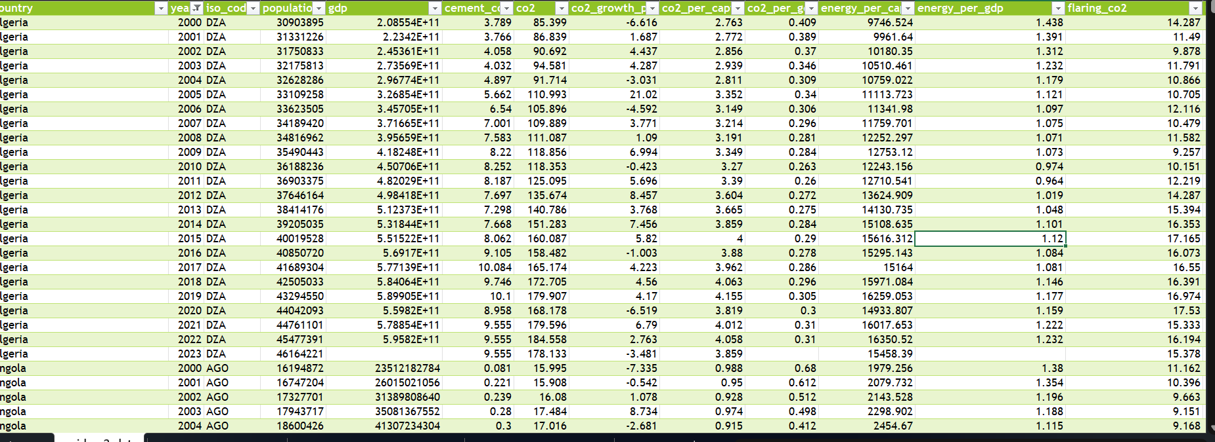
Fig 1: Excel Cleaned Dataset
Step 3: Data Exploration - Microsoft Excel
The following descriptive measures were determined for all the 13 quantitative variables in an Excel sheet entitled EDA Summary. The descriptive measures used include count, minimum, maximum, mean, median, standard deviation, and skewness. Graphs that demonstrate year-on-year trends of Carbon Dioxide, GDP, Carbon Dioxide Growth Rate, Carbon Dioxide per Capita, and Emission Intensity were plotted using pivot tables and line graphs.
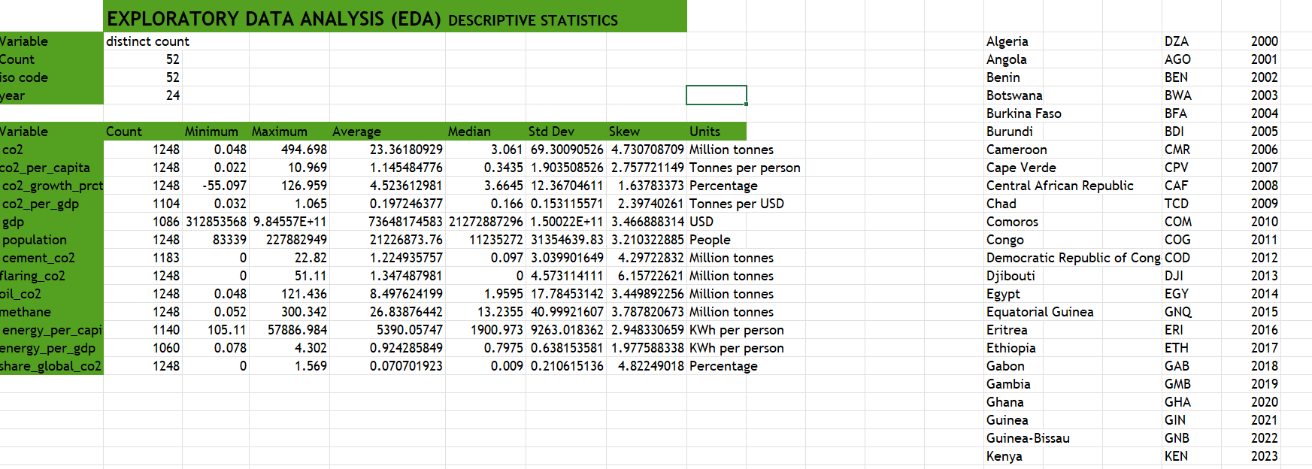
Fig 2: Excel: Descriptive Statistics Table in EDA Summary Sheet

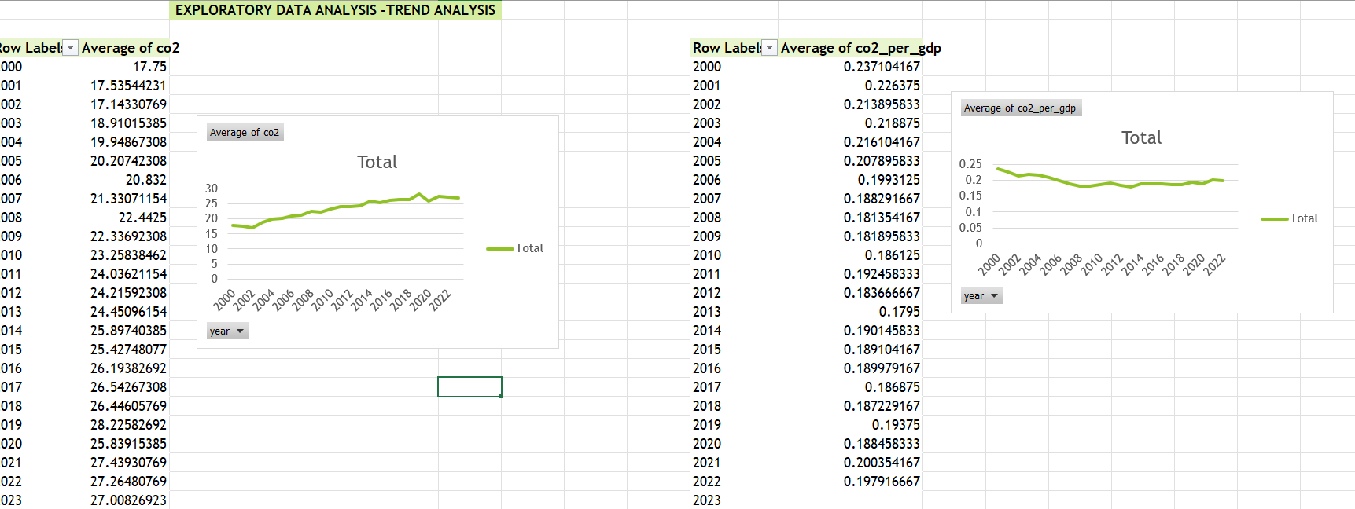
Fig 3: Excel: Trend Analysis Charts (Carbon Dioxide, GDP, Growth Rate, Emission Intensity (2000–2023).

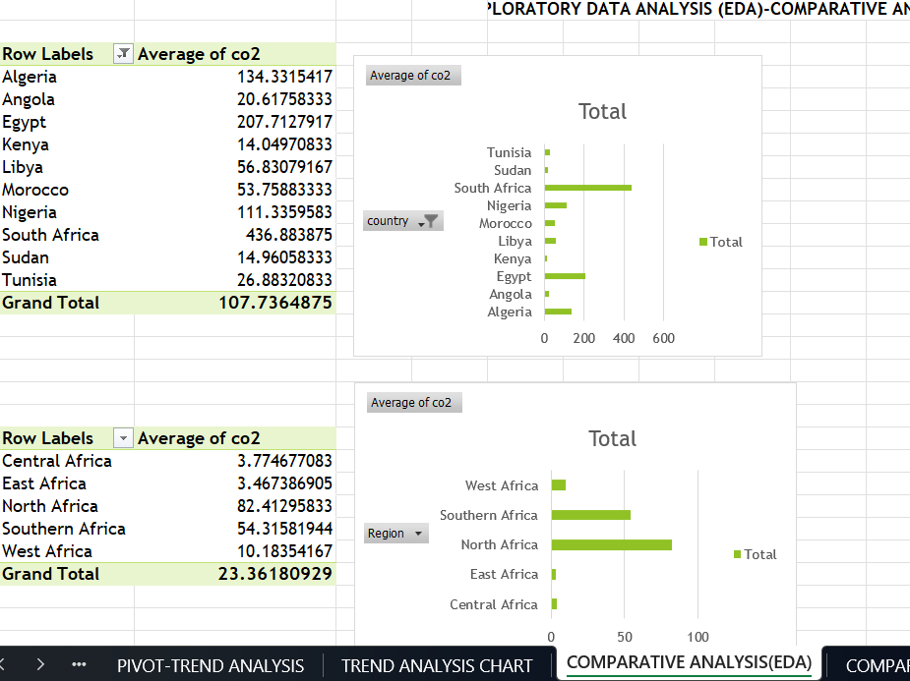
Fig 4: Excel: Comparative Analysis Charts (Top Emitters, Regional Comparison, Carbon Dioxide per Capita).
Phase 4: Analysis Using Structured Query Language – Microsoft SQL Server
A clean database, known as Africa Final, was imported to Microsoft SQL Server Management Studio in the form of a table called co2. A total of thirteen structured queries were developed to generate analytical insight about top emitters, yearly trends, risky countries, decoupling countries, intensity ranking, gas flaring countries, regional comparison, methane emissions, impact on CO2 from coronavirus, energy per capita, percentage of carbon dioxide in the globe, and oil carbon dioxide emissions.
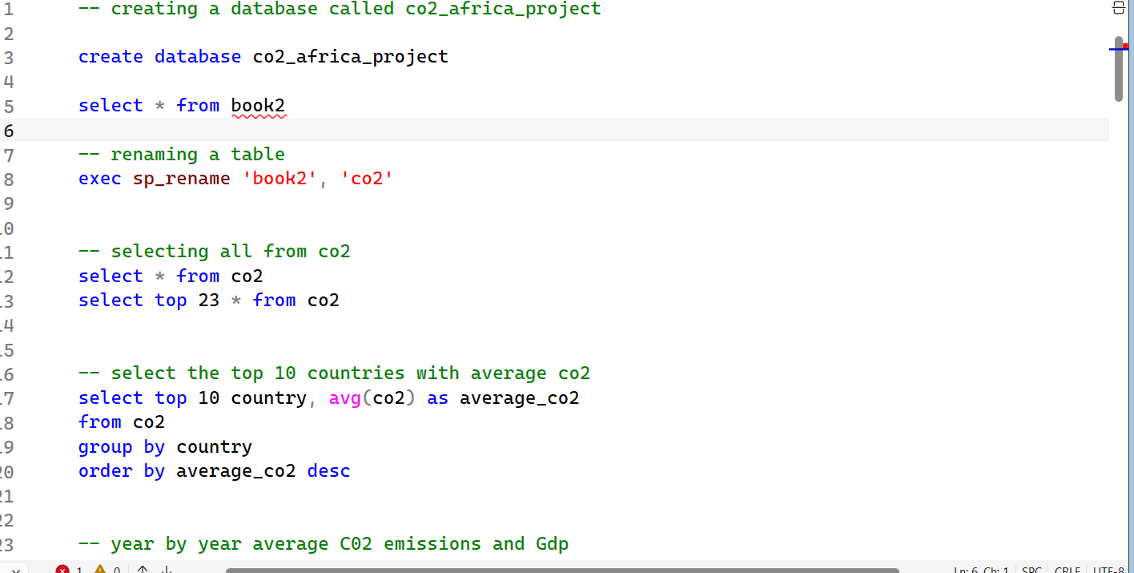
Fig 5: SQL: Sample Query Results (Top 10 African Countries by Average Carbon Dioxide Emissions)
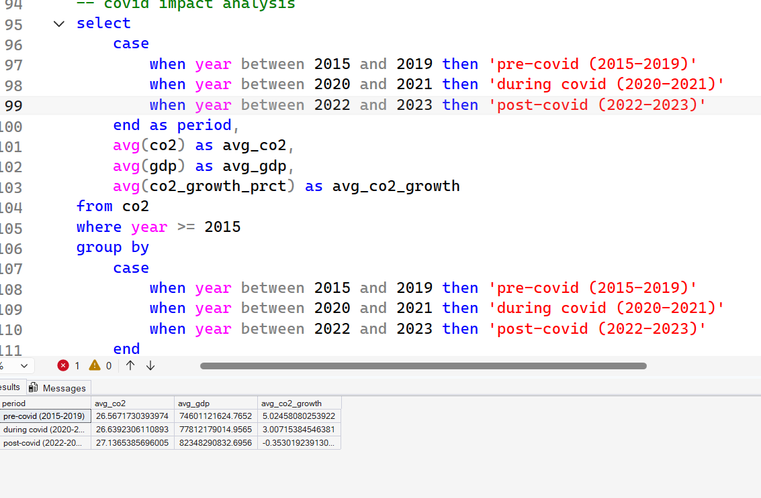
Fig 6: SQL: COVID-19 Impact Analysis Result
Phase 5: Advanced Statistical Analysis- Python (Jupyter Notebook)
The analysis was performed using the Python programming language via the Jupyter Notebook software application from the Anaconda distribution. The cleaned data was successfully imported to check for 1,248 rows and 18 columns in the dataset. Official outliers were identified using the Interquartile Range formula and found that South Africa was identified as an outlier in total carbon dioxide emissions at 494.70 million tons, Nigeria was identified as an outlier in gas flaring and methane production, and Libya was identified as an outlier in carbon dioxide per capita emissions. A correlation heatmap showed that there was a high level of positive correlation between total carbon dioxide, oil carbon dioxide, population, and share of global emissions. The main statistical output was the Pearson Correlation coefficient between Gross Domestic Product and carbon dioxide at 0.7712 with a p-value of 0.000000. Finally, trend analysis showed that carbon dioxide increased by 52.2% while Gross Domestic Product rose 200.6% between 2000 and 2023.
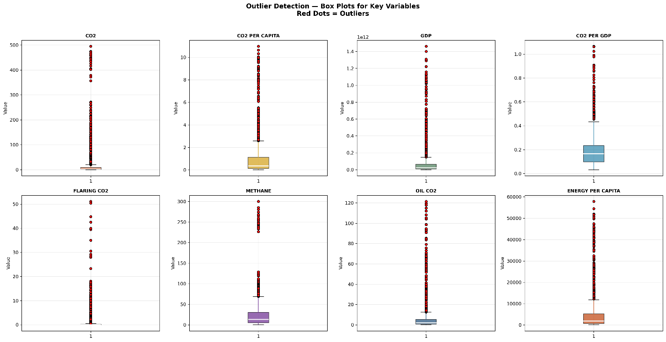
Fig 7: Python: Outlier Detection Box Plots for Eight Key Variables (Red Dots = Outliers).
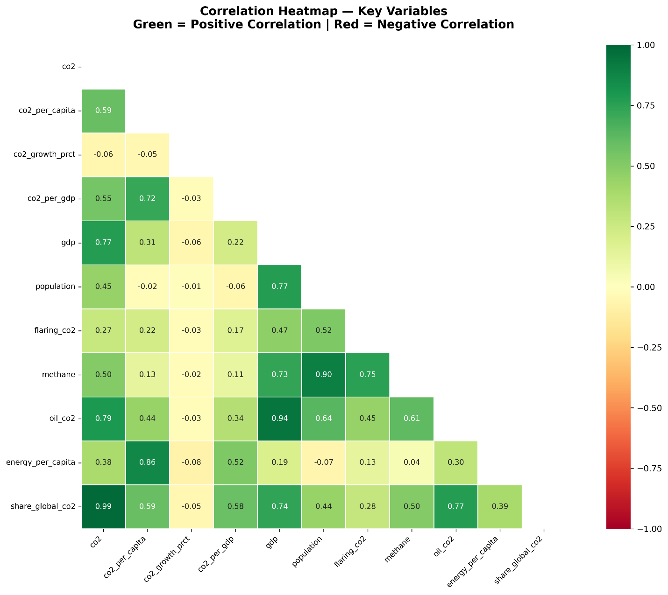
Fig 8: Python: Correlation Heatmap (Green = Positive Correlation | Red = Negative Correlation).
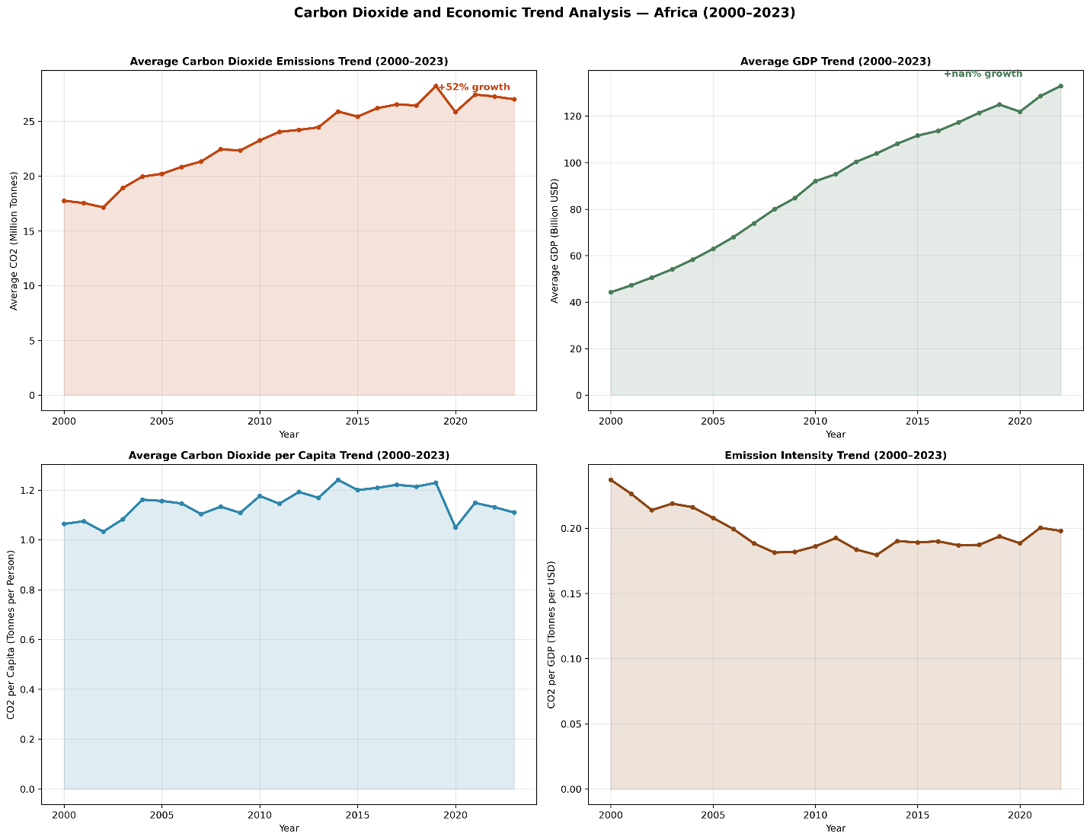
Fig 9: Python: Four-Panel Trend Analysis (Carbon Dioxide, GDP, Carbon Dioxide per Capita, Emission Intensity).
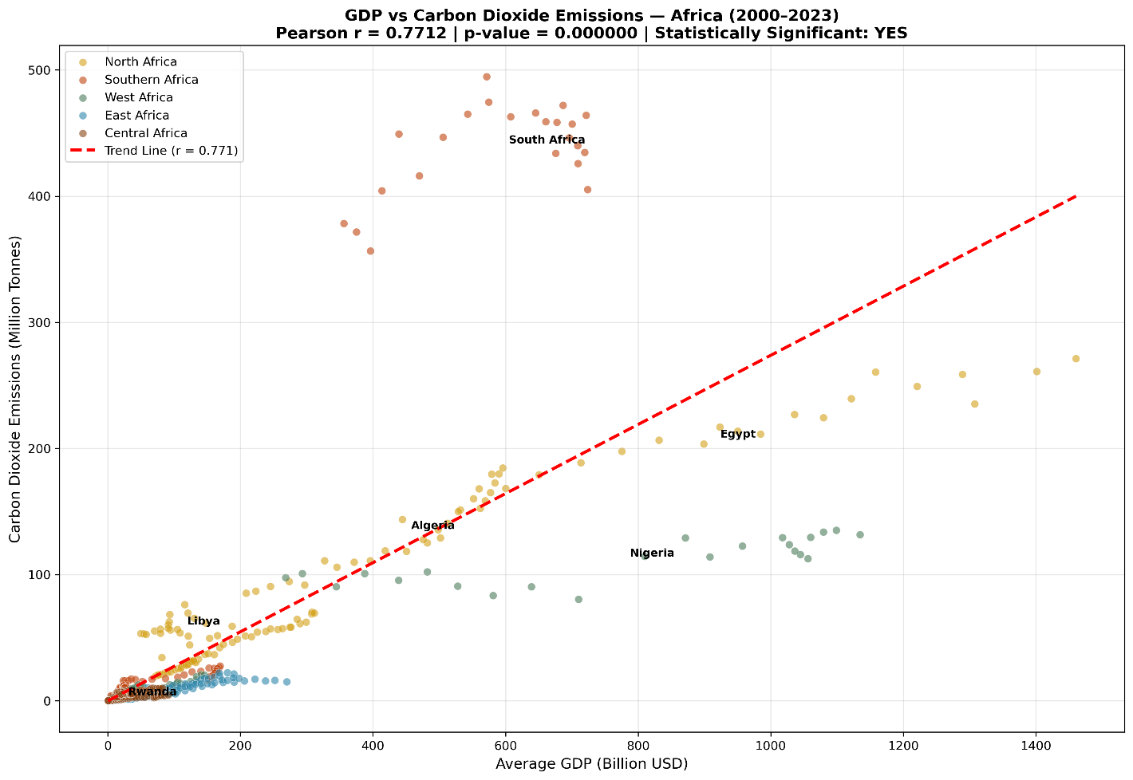
Fig 10: Python: GDP vs Carbon Dioxide Scatter Plot with Regression Line (r = 0.7712).
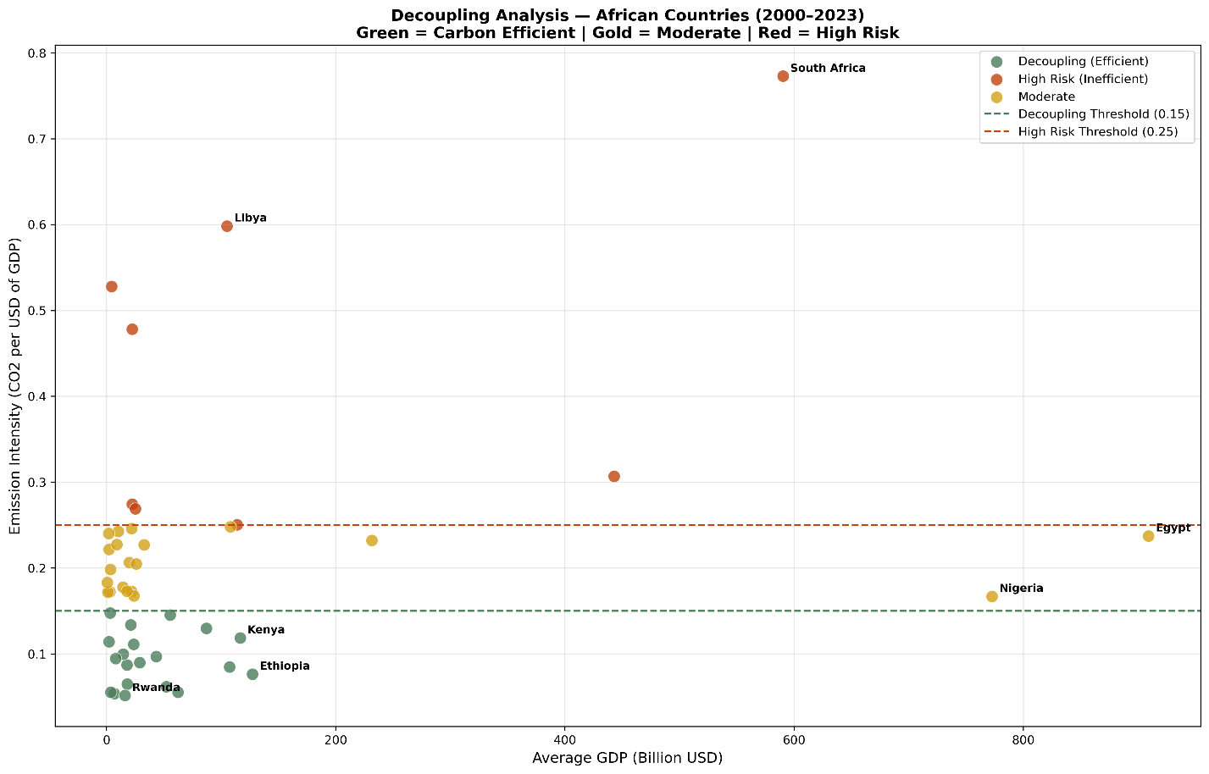
Fig 11: Python: Decoupling Analysis Scatter Plot (Green = Efficient | Gold = Moderate | Red = High Risk).
Phase 6: Interactive Dashboard - Microsoft Power BI
All the cleaned Excel data file and all the SQL query file (a total of 13 tables) were loaded into Microsoft Power BI Desktop. A Star Schema data modeling was created where the Africa Final table acted as the center with other SQL Query tables linked to it through their individual key columns. Six pages were created for the final dashboard with an African theme color scheme consisting of dark brown, golden, green, terracotta and blue colors. Navigation buttons were included to navigate between various pages on the dashboard. Interactive slicers for year, region, and country have been used.
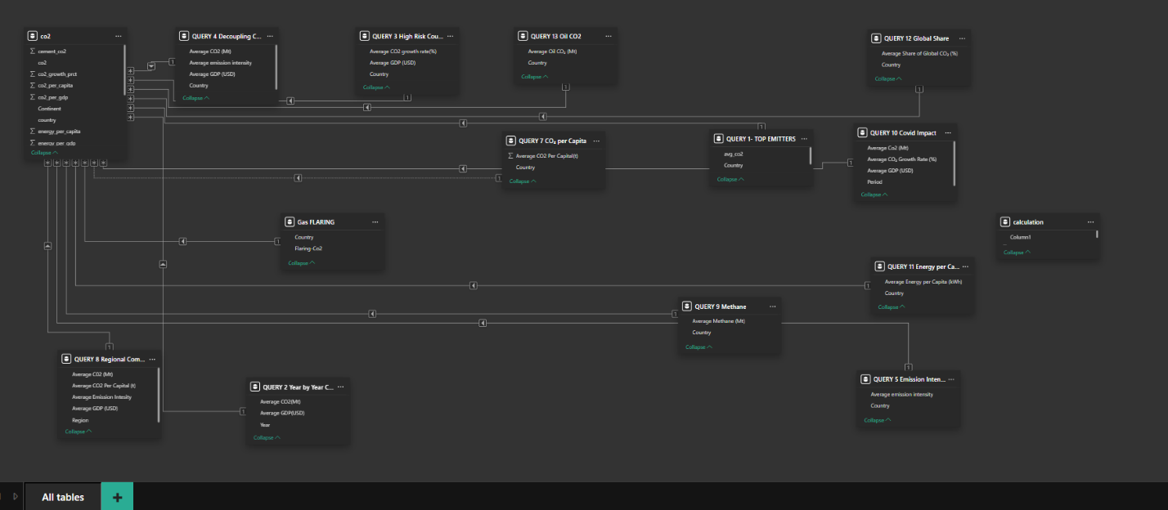
Fig 12: Star schema Model.
Page 1 - Overview Dashboard
This Overview dashboard is made up of four cards representing the averages annual emission of carbon dioxide of 23.03 million tonnes, total country count of 52, South Africa being the top emitter, and the research period of 24 years from the year 2000 to 2023. There are two trend lines that illustrate the African carbon dioxide emission trend and GDP trend during the research period, besides the bar chart of top ten emitters.
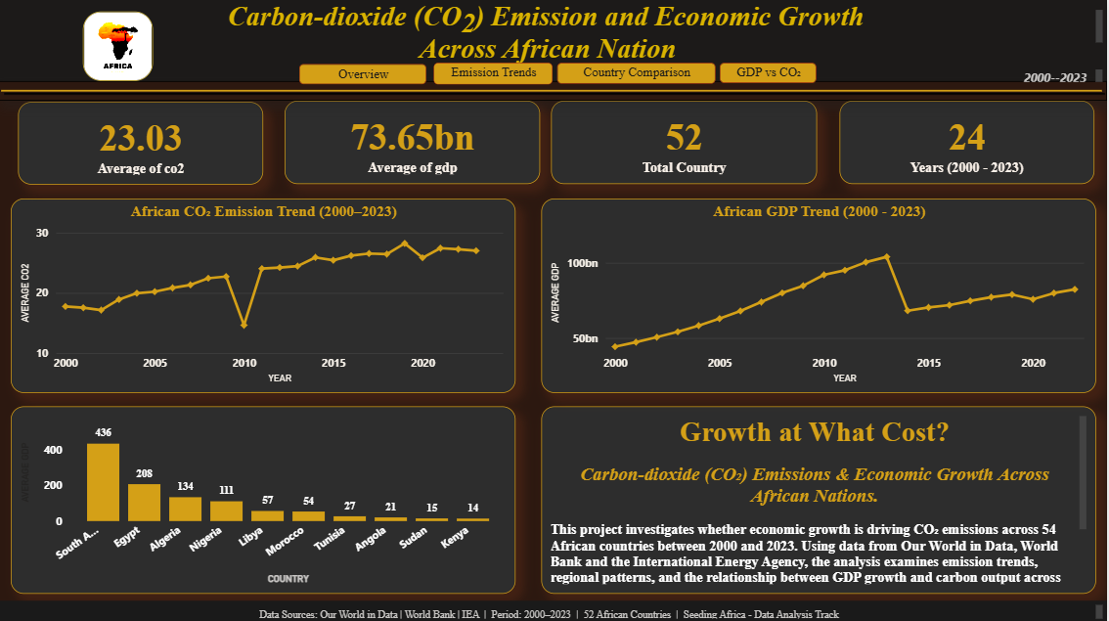
Fig 13: Power BI: Overview Page (KPI Cards, Trend Charts and Top Emitters).
Dashboard Page 2 – Emissions Trends
This page includes six-line graphs for the analysis of the trend of yearly average carbon dioxide emissions, average Gross Domestic Product, carbon dioxide growth rate, carbon dioxide per capita, emission intensity and period comparison between pre- and during COVID-19 periods.
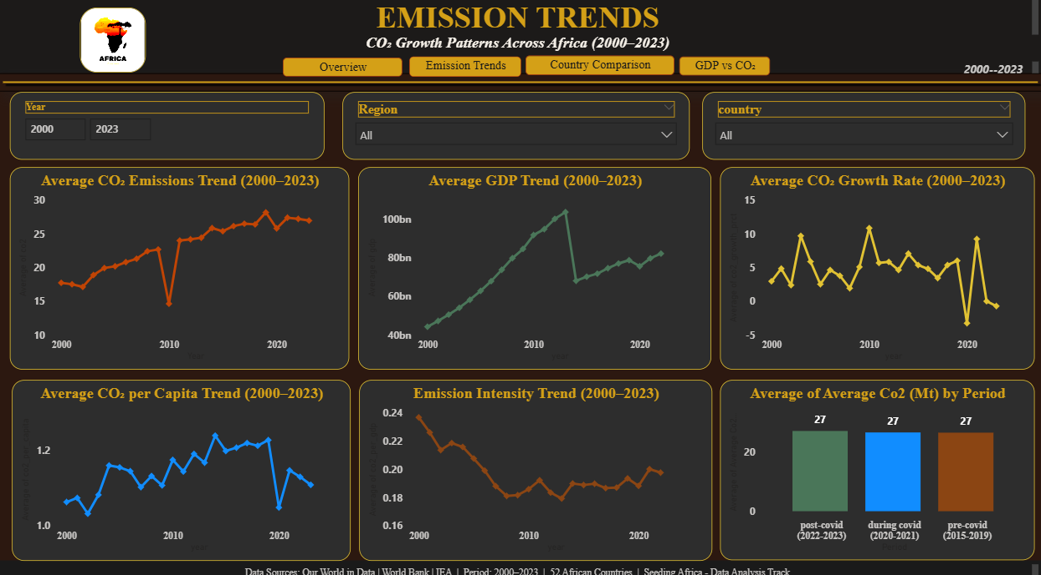
Fig 14: Power BI: Emission Trends Page (five Trend Line Chart).
Dashboard Page 3 – Country & Regional Comparisons
This page provides geographic bubble map for the carbon dioxide emissions by individual countries in Africa. Other graphs included in this page are the top ten emitters, regional average of carbon dioxide, regional average of Gross Domestic Product, top ten carbon dioxide per capita countries, and top ten methane emitting countries.
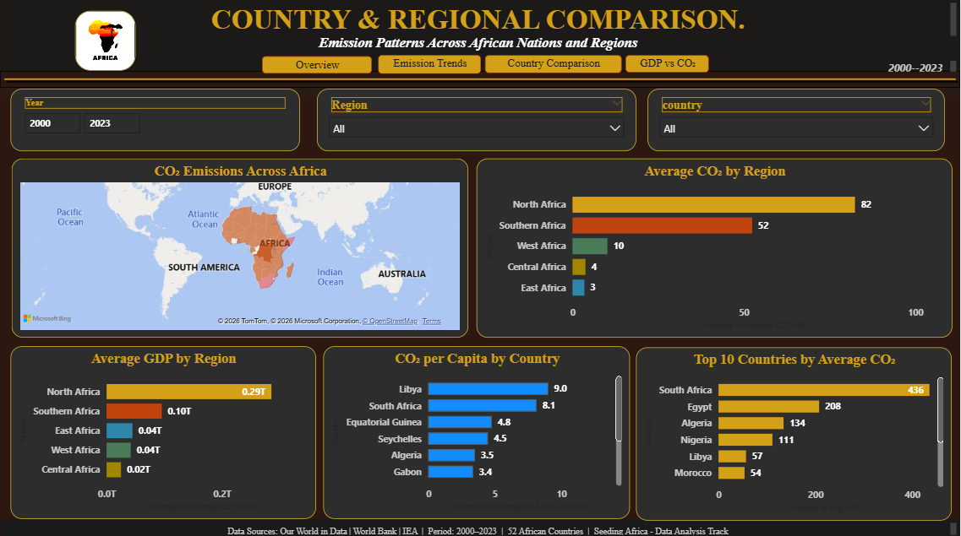
Fig 15: Power BI: Country and Regional Comparison Page (Map and Charts)
Dashboard Page 4 - GDP against Carbon Dioxide and Decoupling Analysis
This page is the main analytical discovery from the project. It features a scatterplot with each of the 52 countries plotted on the basis of their average Gross Domestic Product and carbon dioxide, colored according to the regions they belong. A dual-line graph with year-by-year comparisons of carbon dioxide and GDP trends provide visual confirmation of the decoupling phenomenon. Bar graph ranks all 52 countries in terms of carbon efficiency. This page also includes KPI cards with twenty decoupling countries and forty-three high-risk countries.
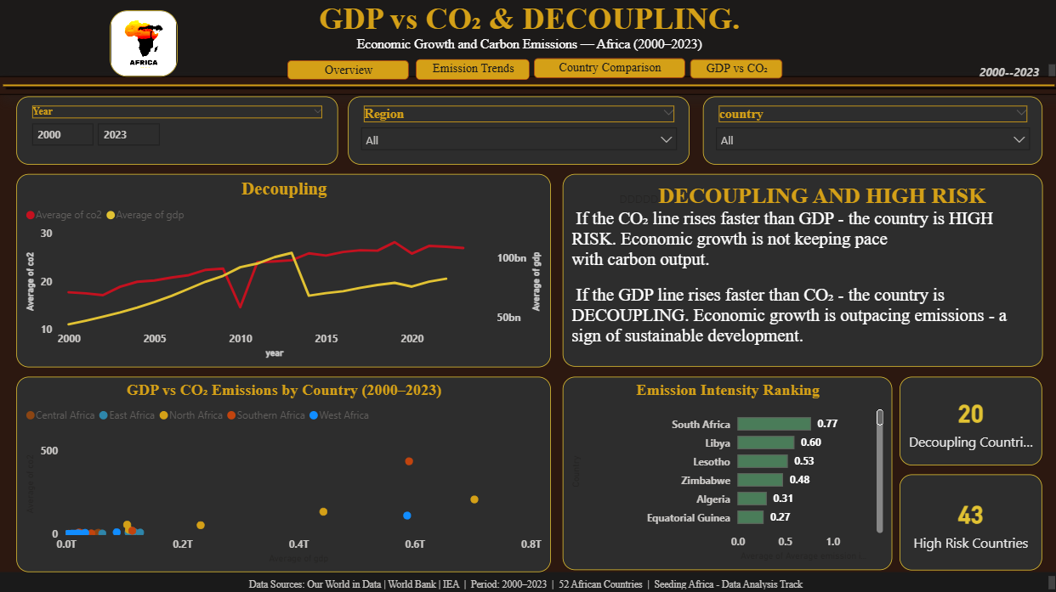
Fig 16: Power BI: GDP vs Carbon Dioxide Page (Scatter Plot, Dual Axis Chart, Emission Intensity Ranking).
Dashboard Page 5 – Sectoral & Global Impact
Page 5 highlights Africa’s carbon footprint in terms of its contribution to sectoral and global sources of carbon dioxide emissions. A KPI card highlights Africa's total share of global carbon dioxide emissions at 3.27 percent. Other graphs include the top ten countries in terms of their contribution to global carbon dioxide emissions, energy per capita, carbon dioxide emissions from oil, methane emissions, and gas flaring.
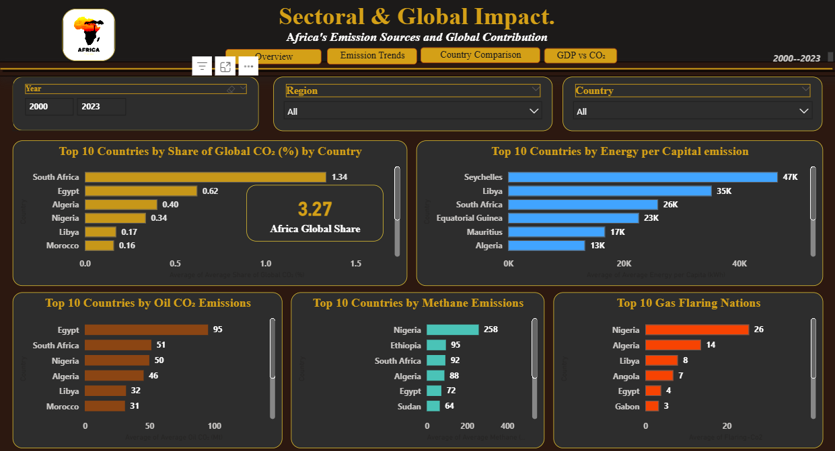
Fig 17: Power BI: Sectoral and Global Impact Page (Global Share, Energy, Oil, Methane, Flaring)
Dashboard Page 6 – Insights & Recommendations
Page 6 wraps up all findings into three sections which include the executive summary, seven insights, and six policy recommendations respectively.
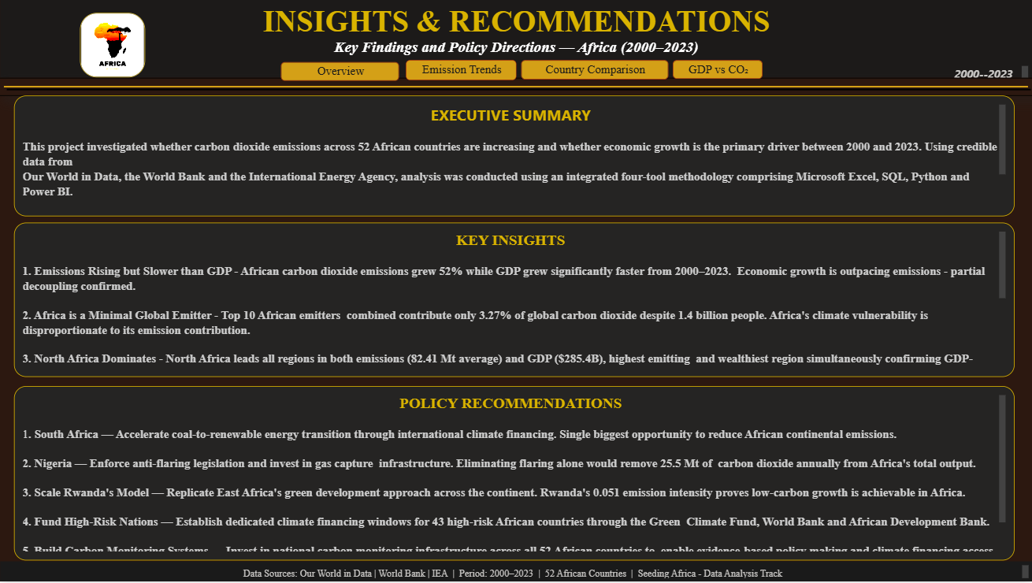
Fig 18: Power BI: Insights and Recommendations Page (Executive Summary, Key Insights, Policy Recommendations).

CHAPTER FOUR
RESULTS AND RECOMMENDATIONS
4.1 Limitations of the Study
All research studies have some limitations and constraints. The following are some limitations that emerged during the execution of this study.

Limitation 1: Absence of Country's Data

Information was found for 52 of the 54 African countries. Western Sahara did not feature in this research because it is not a recognized territory in any way by major organizations such as the World Bank and Our World in Data and thus no independent record on emissions exists for the country. Hence, this study analyzes almost all the countries in Africa.

Limitation 2: Absent GDP Figures

There were 163 missing figures related to the GDP data which pertained to smaller economies in Africa like islands and other post-conflict countries where there were no GDP figures recorded by the World Bank. This affected the emission intensity data which was calculated based on the GDP figure.

Limitation 3: Lack of Sectoral Data at Country Level

The carbon dioxide emissions data based on sectors obtained from the International Energy Agency were only available at the Africa continental level and not at the country level. This made it hard to classify the sources of carbon dioxide at the country level as being from certain sectors such as energy, transportation, etc. In future, data on country level sectoral sources of carbon dioxide should be obtained from national statistics or governments of respective nations.

Limitation 4: Lack of Coal and Gas Carbon Dioxide Data

Carbon dioxide emissions data from coal and from gas sources were dropped from the model because over fifty percent of the data for these variables was missing for most African countries. The reason why coal and gas carbon dioxide data were excluded is because oil carbon dioxide and gas flaring are more complete for most of Africa.

Limitation 5: Omission of LULUCF

Emissions from land use change and forestry could not be included in the calculations as the available data had inconsistencies in their completeness. Thus, carbon dioxide emissions reported throughout the current analysis include those arising from industrial and energy activities only. In this regard, the analysis is likely to underestimate the GHG emissions in African countries where deforestation is common such as the Democratic Republic of Congo and Madagascar.

Limitation 6: Selection of Thresholds

Decoupling threshold was selected as 0.15 tonnes of emission per one dollar of GDP while the high-risk category threshold was set at more than 5% annual rate of CO2 emissions increase. The selected thresholds were defined on the basis of the results of exploratory data analysis of average figures for the African continent. The thresholds are subjective decisions and different thresholds would result in reclassifications. Sensitivity analysis is recommended for future research.

Limitation 7: One Economic Indicator

The Gross Domestic Product was chosen as the sole economic indicator for this study. Although GDP is the most widely comparable measurement for the level of economic activity in any economy, it does not include other aspects such as distributional concerns like income inequality, sectoral mix, or even the level of quality in the energy policies of each country. Future studies should use other economic indicators for a richer analysis of the growth-emissions relationship.

Limitation 8: Absence of 2023 GDP Figures

Complete 2023 GDP data was not yet provided by the World Bank. As a result, the year 2023 will display an absence of GDP figures when examining annual GDP data trends. CO2 emission data for the year 2023, however, was provided by Our World in Data and was used for CO2 emissions trend analysis.

4.2 Recommendations for Future Research

In view of the results and limitations of this research, there are some recommendations that can be put forward for future researchers to pursue.

- Future research should use the sector-specific carbon dioxide emissions data at the country level to help analyze and find out in which particular sector – electricity, transport, industries, residential sectors – the increase in carbon dioxide emissions takes place within each individual African country.
- Another factor of importance that can influence emissions can be the energy mix used by each of these countries. It is possible to examine whether the percentage of renewable energy versus non-renewable energy used by each of these countries contributes to their carbon dioxide emission differences.
- By conducting a longitudinal study over a period of time with intervals of five years in which the decoupling phenomenon would be studied among the 52 African countries, more valid findings about decoupling can be achieved. Moreover, this longitudinal approach will enable us to investigate whether countries that are categorized as high risk today are moving towards or away from sustainable development.
- In order to make predictions about the CO2 emissions trajectory of different African countries based on the growth rate scenario, predictive models and machine learning algorithms should be employed by future research.
- The impact of governmental policies regarding climate change such as carbon taxes, renewable energy investments, and international climate change agreements on CO2 emissions should be taken into account as another independent variable in future studies to find out whether policy making has any effect on growth-emission linkage.
- Sensitivity analysis must be conducted on the decoupling and high-risk thresholds used in this study to evaluate the validity of classifications made through such thresholds.

4.3 Main Findings and Benefits of the Project
Several major findings emerged during the course of this project that have implications for policy making and are useful for many interested parties in Africa and the global climate arena.

Key Finding One: Africa Is a Minimal Global Emitter
The combined contribution of the top ten emitters of carbon dioxide on the continent accounts for only 3.27% of the global share of CO2 emissions. On average, each country in Africa produces only 0.009% of total global emissions. This finding underscores the fact that Africa’s development should not be limited by the same stringent emissions restrictions that developed countries had been following over the past decades, leading to the current climate crisis experienced in Africa.
Key Finding 2: GDP Growth Rate outpaces CO2 Emission Growth Rate
From 2000 to 2023, the growth rate of carbon dioxide emissions stood at about 52%, while the gross domestic product of the continent grew significantly faster over same period. This is one of the most important findings from the study as it shows that partial decoupling has been happening on a continental scale within Africa. The continent's economic development is no longer directly linked to corresponding increases in emission, indicating the gradual development of a carbon-efficient continent.

Key Finding 3: North Africa and Southern Africa Are the Most Significant Contributors to Carbon Emission on the Continent. The region with the highest average carbon dioxide emission is North Africa, which records an average emission rate of 82.41 million tonnes alongside a GDP of 285.4 billion dollars. In addition, Southern Africa follows with an average emission rate of 52.41 million tonnes, mostly from South Africa. The energy sectors in the two regions use fossil fuels to meet energy demand and also feature industrialized economies.
Key Finding 4: East Africa is the Decoupling Champion.

It is noteworthy that East Africa has been found to be the most carbon-efficient region in terms of emissions per GDP. It has an average emission intensity of 0.122 tonnes of carbon dioxide per unit of gross domestic product. Some of the most efficient countries in the entire continent include Rwanda, Uganda, Ethiopia, Tanzania, and Kenya. Notably, Rwanda has the least emission intensity on the continent with figures standing at 0.051. This figure is proof that economic development can take place without proportionate carbon emissions. East Africa should, therefore, be taken as an example for other parts of the continent.

Key Finding 5: Multi-Sector Intervention Required in Nigeria

Nigeria was identified as an important country that needs immediate attention on several levels. First of all, it emits the highest amount of gas flares in the continent with a yearly total of 25.5 million tonnes. It is almost double the emissions emitted by Algeria, which is second place. Furthermore, Nigeria has the highest methane emissions on the continent with figures standing at 258.4 million tonnes per year. Despite being Africa's economic powerhouse, Nigeria is recording high carbon dioxide emissions at 13.5 percent annual rate.

Key Finding 6: South Africa is the Least Efficient African Economy in Terms of CO2 Emissions

South Africa is the highest emitting country in Africa, generating carbon dioxide at a rate of 435.7 million tonnes annually, more than twice that of the runner up, Egypt. South Africa also has the highest CO2 emission intensity ratio at 0.773 tonnes per dollar of Gross Domestic Product, making its economy fifteen times less efficient than Rwanda in carbon dioxide terms. The main cause of inefficiency in South Africa is its coal-dominated energy production system. A specific energy transition program that shifts South Africa away from coal towards renewables will make the biggest difference to Africa’s CO2 emissions.

Key Finding 7: Impact of the Pandemic on Africa's Emissions Structure

There was a significant drop in carbon dioxide emissions worldwide due to the outbreak of the pandemic where industries, transport, and other forms of economic activities ceased to operate. However, there was a minimal change in the levels of carbon dioxide emissions in Africa from 2020 to 2021, indicating that they were constant despite the pandemic outbreak. This indicates that the major sources of emissions in Africa are from agriculture, basic energy needs, and day-to-day activities rather than industries.

SOLUTIONS AND ADVANTAGES OF THE PROJECT
Not only have issues been pointed out, but this project also provides six feasible solutions based on facts which can be implemented by governments, developmental organizations, financial organizations for climate change, and other policymakers from Africa and internationally.
Solution 1: Speeding Up the Shift from Coal-based to Renewable Energy Production in South Africa
South Africa produces 435.7 million metric tons of CO2 each year, which is more than twice that of any other country in Africa. It is one of the largest producers of CO2 through its electricity production because it still relies mostly on coal. A significant step forward would be to increase the speed of switching from coal to renewable energy such as wind, solar, and hydropower in South Africa. Climate finance institutions need to help fund this transition.
Solution 2: End Gas Flaring in Nigeria by Legislation Enforcement and Infrastructure Investments
Nigeria is responsible for releasing 25.5 million metric tons of CO2 solely because of gas flaring. Nigeria has been known to release a lot of gas from their oil drilling operations because of the lack of infrastructure to capture and use this gas. This can be done by enforcing current laws that prevent flaring, investing in proper infrastructure to gather gas, and providing financial incentives to oil companies. Annual reduction goals for gas flaring should be set up.
Solution 3: Replicate Rwanda's Green Growth Model in Other Parts of Africa
Rwanda shows that it is possible to achieve fast economic growth and keep emissions at extremely low levels. Indeed, with the country's emission intensity of only 0.051 tonnes per dollar of GDP, the lowest in all of Africa, the green growth model employed by Rwanda can serve as a blueprint. The governments and other partners working with the African Union countries need to understand, record, and replicate Rwanda's green growth strategy in East, Central, and West Africa.
Solution 4: Create Climate Financing Funds for Africa's Risky Countries
According to this paper, there are forty-three countries in Africa that are classified as high risk.
While many countries like Mozambique, Sierra Leone, Tanzania, and Ethiopia are developing rapidly, they do not have sufficient finances to invest in sustainable energy solutions. Thus, international climate financing organizations such as the Green Climate Fund, the World Bank, and the African Development Bank should develop special funds for high-risk African countries.
Solution 3: Replicate Rwanda’s Green Growth Development Strategy for the Entire Continent of Africa
The nation of Rwanda proves that rapid economic development and low levels of carbon dioxide emissions are not incompatible goals. In fact, with an emission intensity of only 0.051 tonnes per dollar worth of GDP (the lowest in Africa), Rwanda serves as an example that should be replicated. Indeed, member states of the African Union and its development partners need to study, catalogue, and emulate Rwanda’s green growth strategy involving investments in clean energy sources, tree-planting programs, and green buildings.
Solution 4: Create Climate Funding Programs for Africa’s High-Risk Nations
Ninety-five percent of nations included in our research were classified as high-risk by the study.
Of those nations, many such as Mozambique, Sierra Leone, Tanzania, and Ethiopia, are fast-developing nations that simply do not have enough money to invest in their own clean energy development infrastructure. Consequently, funding organizations for climate initiatives such as the Green Climate Fund, the World Bank, and the African Development Bank should create special funding channels for Africa’s high-risk nations.
Solution 5: Adopt Nationally-Based Carbon Monitoring Systems in Africa
One of the major shortcomings of this project was the lack of country-level sectorial carbon dioxide data for many countries in Africa. For any government to be able to adopt sound policies or receive some climate financing opportunities, there must be data for measuring, reporting and verification. African governments, together with their international development partners, need to consider investing in nationally-based carbon monitoring systems where emissions can be tracked on a per-sector basis.
Solution 6: Enhance African Ministries’ Ability to Analyze Data
It is among the greatest strengths of this project that it has demonstrated the immense potential in conducting integrated data analyses using Excel, SQL, Python and Power BI tools in extracting useful information out of freely available data without incurring high costs.
It would be prudent for the African governments, as well as development agencies, to build their capacity to analyze data using freely available data sources, such as Our World in Data, World Bank, and International Energy Agency.

CHAPTER FIVE
5.1 Conclusion
The objective of this project has been to establish whether carbon dioxide emissions in different countries of Africa have been on the rise over time, and if the reason behind that was economic development. The answer, according to the data, is quite different and more positive than many people can believe.
Carbon dioxide emissions are indeed on the rise in Africa. They rose from an average of 17.75 million tons per country in 2000 to 27.01 million tons in 2023, marking an increase of 52% over 23 years. However, the emissions need to be viewed in their proper context. Gross Domestic Product, meanwhile, has grown by significantly faster during the same period, twice as fast as emissions have increased. This means that the economic efficiency of African nations in terms of carbon use has been improving all the while. They are doing what they can to lift their population out of poverty without meeting the standards that were never created for them anyway.
This makes the findings at the regional and national levels quite significant in giving additional detail to this continental narrative. The northern and southern regions of Africa, which are the most industrially developed parts of the continent with the highest dependence on fossil fuels, contribute to most of the continent's emissions and require immediate interventions through green energy solutions.
However, at the same time, the experience of East Africa, and, especially, that of Rwanda, whose economic growth does not have adverse effects on the environment due to achieving 0.051 of emission intensity, shows that another scenario is possible. Indeed, there are twenty African nations that grow economically independently of their greenhouse emissions.
It should come as no surprise that one of the most revealing statistics from this study may very well be the fact that the ten largest African nations account for only 3.27 percent of total global CO2 emissions despite accounting for seventeen percent of the planet’s total population. This statistic alone is worth bringing into any discussion on climate financing, the right to development, and environmental justice across the globe. Africa is not responsible for the climate crisis. But Africa must still make the payments.
The strength of the integrated approach to data analytics through the use of Excel, SQL, Python, and Power BI cannot be overstated. It shows what incredible tool integrated data analytics can be in terms of extracting meaning and communicating it to audiences who are capable of making important decisions. The hope of this writer is that the findings presented here serve in some way towards this end.
RECOMMENDATION
From the perspective of a personal stakeholder in this research work, there are certain issues that other stakeholders, which can be governments, development organizations, climate finance institutions, educators, among others, need to focus on because of insights obtained from this data.
In the first place, there is one thing that should be done, more urgently than anything else from this data analysis and project report, and that is something country-specific, not continent-wide. Both South Africa and Nigeria are responsible for a major portion of African carbon dioxide emissions problems. South Africa due to coal-powered electricity systems while Nigeria due to gas flaring. Any attempt to solve the problem of African carbon dioxide emissions would require addressing these two countries in particular.
Moreover, according to the findings of this study, East Africa, and specifically, Rwanda, have quietly developed one of the most carbon-efficient models of economic development in the world. The emission intensity of 0.051 tons of CO2 per dollar GDP in Rwanda was not just a coincidence; it is the direct result of certain policies related to clean energy and green infrastructural investments. States within the African Union, along with development banks and their governments, should be analyzing the model that Rwanda followed and providing it financial assistance to be replicated in riskier states before another decade of observations is needed.
Third, this project shows that highly valuable policy insights can be gained from publicly accessible data at zero cost. Our World in Data, the World Bank, However, none of the government ministries in Africa have such departments that generate insights using the above methods for their decision makers. From my perspective, educational establishments, development partners, and government institutions should make it their top priority to invest in developing such expertise on a continental scale. It would enhance the effectiveness of climate finance expenditures by multiple times, as those based on insights will benefit the targeted individuals.
Fourth, the discovery that Africa's top ten emitters produce only 3.27 percent of the world's carbon dioxide emissions yet have seventeen percent of the population in the world is a figure that all leaders from Africa, all climate change negotiators, and all those financing development projects need to take to every negotiating table and every boardroom. Africa is not responsible for the climate problem. Yet African people, farmers, fisherfolk, pastoralists, coastal dwellers bear the brunt of the damage done by climate change. This study forms just one part of making that case.
Finally, personally speaking, this project has further strengthened my belief that data analysis is among the most important tools we have to tackle developmental challenges in Africa. Given that I was previously exposed to studying mathematics education, I have learned that the abstraction involved in mathematical principles becomes concrete when linked to practical problems. The techniques used in analyzing data in this particular project are applicable anywhere else in the world. Anyone, including students and researchers, with a computer and an internet connection can analyze freely available data using Excel, SQL, Python, and Power BI. Future leaders need to base their decisions on evidence and not on conjecture. Africa is not lacking in data. It just needs data analysts to help in interpreting the data and drawing conclusions from the findings. The next generation of Africans will know how to hold governments accountable because they will know how to critically analyze statistics presented.
REFERENES
African Development Bank Group. (2022). African economic outlook 2022: Supporting climate resilience and a just energy transition in Africa. African Development Bank Group. https://www.afdb.org/en/documents/african-economic-outlook-2022
Asongu, S. A., & Nwachukwu, J. C. (2016). The role of governance in mobile phones for inclusive human development in Sub-Saharan Africa. Technovation, 55(1), 1–13. https://doi.org/10.1016/j.technovation.2016.01.003
Bekun, F. V., Alola, A. A., & Sarkodie, S. A. (2019). Toward a sustainable environment: Nexus between CO₂ emissions, resource rent, renewable and nonrenewable energy in 16-EU countries. Science of the Total Environment, 657, 1023–1029. https://doi.org/10.1016/j.scitotenv.2018.12.104
Dietz, T., & Rosa, E. A. (2017). Rethinking the environmental impacts of population, affluence and technology. Human Ecology Review, 4(2), 277–300.
Elvidge, C. D., Zhizhin, M., Baugh, K., & Hsu, F. C. (2016). Automatic boat identification system for VIIRS low light imaging data. Remote Sensing, 7(3), 3020–3036. https://doi.org/10.3390/rs70303020
Esso, L. J., & Keho, Y. (2016). Energy consumption, economic growth and carbon emissions: Cointegration and causality evidence from selected African countries. Energy, 114, 492–497. https://doi.org/10.1016/j.energy.2016.08.010
Grossman, G. M., & Krueger, A. B. (1991). Environmental impacts of a North American free trade agreement (Working Paper No. 3914). National Bureau of Economic Research. https://doi.org/10.3386/w3914
International Energy Agency. (2022). Africa energy outlook 2022. IEA. https://www.iea.org/reports/africa-energy-outlook-2022
International Energy Agency. (2023). CO₂ emissions from fuel combustion in Africa [Dataset]. IEA. https://www.iea.org/regions/africa/emissions
Our World in Data. (2023). CO₂ and greenhouse gas emissions [Dataset]. Our World in Data. https://ourworldindata.org/co2-emissions
Panayotou, T. (1993). Empirical tests and policy analysis of environmental degradation at different stages of economic development (Working Paper WP238). International Labor Organization.
Ritchie, H., & Roser, M. (2020). CO₂ and greenhouse gas emissions. Our World in Data. https://ourworldindata.org/co2-and-other-greenhouse-gas-emissions
World Bank. (2023). World development indicators: GDP per capita (current US$) [Dataset]. World Bank Open Data. https://data.worldbank.org/indicator/NY.GDP.PCAP.CD
World Bank. (2023). World development indicators: GDP per capita growth (annual %) [Dataset]. World Bank Open Data. https://data.worldbank.org/indicator/NY.GDP.PCAP.KD.ZG

